Formula:
xv = xv_min + (xw - xw_min) * (xv_max - xv_min) / (xw_max - xw_min)
yv = yv_min + (yw - yw_min) * (yv_max - yv_min) / (yw_max - yw_min)
Python code:
# Window coordinates
xw_min, yw_min = 0, 0
xw_max, yw_max = 100, 100
# Viewport coordinates
xv_min, yv_min = 200, 200
xv_max, yv_max = 400, 400
# Point in window
xw, yw = 50, 75
# Transform window → viewport
# scaling and shifting formulas.
#keeping the same relative position inside both boxes.
xv = xv_min + (xw - xw_min) * (xv_max - xv_min) / (xw_max - xw_min)
yv = yv_min + (yw - yw_min) * (yv_max - yv_min) / (yw_max - yw_min)
print("Mapped point in viewport:", xv, yv)
output:
Mapped point in viewport: 300.0 350.0
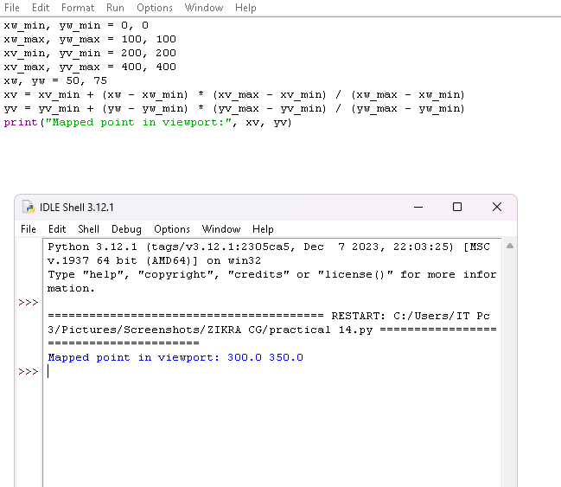

Explanation of code:
Code | Simple Meaning
xw_min, yw_min = 0, 0 | Window’s bottom-left corner is (0,0).
xw_max, yw_max = 100, 100 | Window’s top-right corner is (100,100). So window size = 100×100.
xv_min, yv_min = 200, 200 | Viewport’s bottom-left corner on screen is (200,200).
xv_max, yv_max = 400, 400 | Viewport’s top-right corner is (400,400). So viewport size = 200×200.
xw, yw = 50, 75 | A point inside the window — halfway in x (50) and ¾ up in y (75).
xv = xv_min + (xw - xw_min) * (xv_max - xv_min) / (xw_max - xw_min) | Converts x = 50 from window to viewport → gives xv = 300.
yv = yv_min + (yw - yw_min) * (yv_max - yv_min) / (yw_max - yw_min) | Converts y = 75 from window to viewport → gives yv = 350.
print("Mapped point in viewport:", xv, yv) | Prints the new screen position of the same point.

